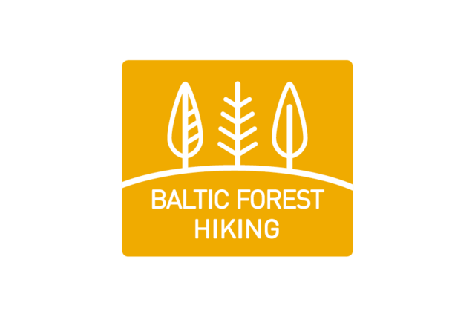
Dear partners, 23.08.2022.
We would like to take the opportunity to inform you about our latest active tourism products: the Baltic Forest Hiking Route, the Baltic Coastal Hiking Route and the available Tours.
The three Baltic countries are now linked with the European network of long distance hiking paths prolonging the routes E9 and E11.
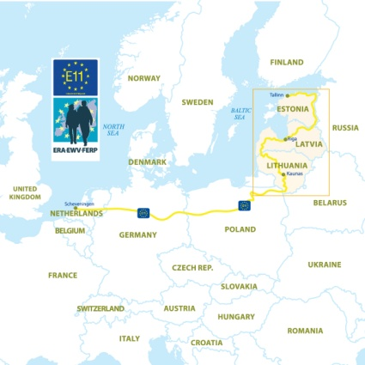
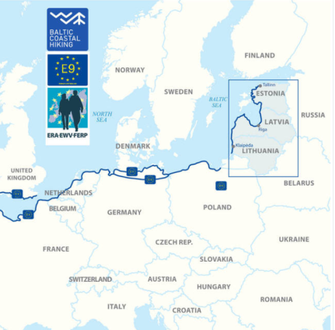

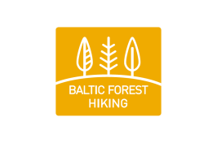

What is the Baltic Forest Trail Hiking Route? The Forest Trail is a part of the European long-distance hiking route E11. In the Baltic countries, the trail leads through the most beautiful forests and national parks of Lithuania, Latvia, and Estonia. It starts in Lazdiai town on the Polish – Lithuanian border, crosses Latvia, turning into Riga and arrives in Tallinn, Estonia. Length of the trail ~ 2140 km.
What is the Baltic Coastal Hiking Route? It is a long-distance hiking route, part of the European hiking route E9, which goes along the Baltic Sea coastline in Lithuania, Latvia, and Estonia. The hiking route starts at the Russian-Lithuanian border in the village of Nida and finishes at the port of Tallinn in Estonia. The route can be taken in both directions which means that Tallinn can also be the starting point. Length of the trail is 1419 km and goes through two capital cities whose old towns have received UNESCO site status: Riga and Tallinn. More information and maps about the Baltic trails can be found on the specially designed website https://baltictrails.eu/en.
Fully completed – with marking signs, maps, guidebooks and a specialised website – the Baltic Trails are offering marvellous nature experiences to hikers in Estonia, Latvia and Lithuania. The Trails are gaining more and more popularity in the community, on social networks and other media channels, both nationally and internationally. For example, this summer Lonely Planet published several articles on Baltic Hiking trails as one of the best new long-distance hiking trails for 2022 (https://www.lonelyplanet.com/articles/travel-trends-long-distance-hikes).
The Hiking Tours.
On the website you will find also specially prepared hiking tours https://baltictrails.eu/en/coastal/tours and https://baltictrails.eu/en/forest/tours, itineraries for one and multiple days, and the most colourful stretches of the Baltic Hiking routes. Every tour includes a schematic tour map, information about the mileage per day, level of difficulty, sightseeing objects, and practical information. The tours can also be shortened and included as a part of your already planned tourism routes to diversify the offer. If you are interested in any of the marketing materials, we can mail them to you.
Who can use the tours? The tours can be used for both – individual travellers and small or tourist groups.
Best regards,
Asnate Ziemele
Chair person
Ph.+37129285756, asnate@celotajs.lv

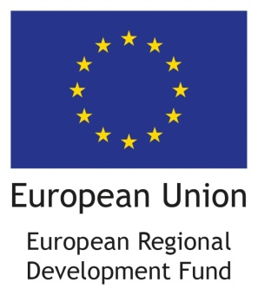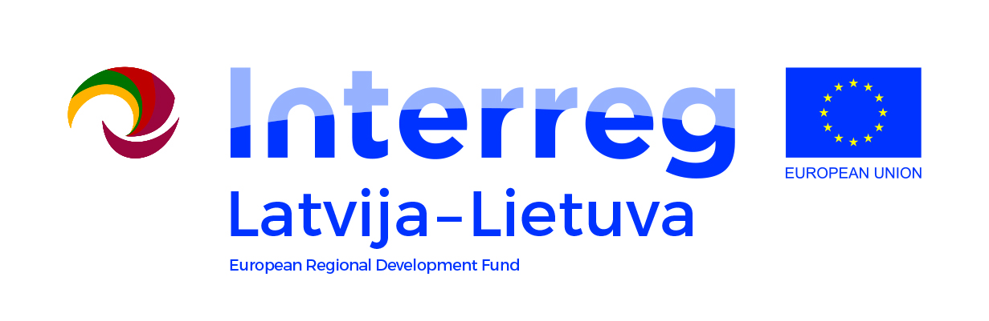
Project LLI-448 “Development of Forest trail in Latvia and Lithuania and expanding the Baltic Coastal Hiking route in Lithuania” (Hiking project) is being implemented with the support of the European Union Interreg V-A Latvia–Lithuania Cross Border Cooperation Programme 2014–2020. Total costs of the project are EUR 788,104. Co-funding by the European Regional Development Fund is EUR 669,888.
This publication has been produced with the financial assistance of the European Union. The contents of this publication are the sole responsibility of Latvian country tourism association „Lauku ceļotājs” and can under no circumstances be regarded as reflecting the position of the European Union.

